WEATHERWISE AI API
Backend Development – Project Documentation

Naan Mudhalvan – Skill Wallet Group Project

Project Topic: AI WeatherWise API

1. Project Overview
WeatherWise AI API is a backend service designed to provide secure and scalable REST APIs for weather-related and AI-powered application features. The backend is built using Node.js and Express.js and uses MongoDB for data storage. It supports authentication, study material management, AI-powered content generation, and administrative operations.

2. Core System Script Implementations

2.1 Application Entry Point (index.js)
The index.js file serves as the main entry point of the application. It initializes the Express server, loads environment variables, configures middleware, establishes the MongoDB connection, registers API routes, and starts the server after a successful database connection.

2.2 index.js Implementation
const app = require('./app');
const connectDB = require('./config/db');
const PORT = process.env.PORT || 5000;
connectDB()
.then(() => {
app.listen(PORT, () => {
console.log(`Server running on port ${PORT}`);
console.log('Press Ctrl+C to terminate.');
});
})
.catch((error) => {
console.error('Database connection failed. Express server aborted:', error.message);
process.exit(1);
});

3. Code Explanation
const app = require('./app'); Imports the Express application configuration from the app.js file.
const connectDB = require('./config/db'); Imports the database connection function used to connect the application to MongoDB.
const PORT = process.env.PORT || 5000; Reads the port number from the environment variables. If no port is configured, port 5000 is used.
connectDB().then(...) Attempts to establish the MongoDB connection before starting the Express server.
app.listen(PORT, ...) Starts the Express server and displays a message indicating the port on which the server is running.
.catch((error) => ...) Handles database connection failures, prints the error message, and terminates the application safely.

4. Environment Configuration
Create a .env file in the project root directory and configure the required environment variables. Environment variables are used to keep sensitive configuration values outside the source code.
PORT=5000
MONGO_URI=your_mongodb_connection_string
JWT_SECRET=your_jwt_secret
GEMINI_API_KEY=your_gemini_api_key

5. Environment Variable Description
Variable | Purpose
PORT | Defines the port on which the Express server runs.
MONGO_URI | Stores the MongoDB database connection string.
JWT_SECRET | Secret key used for JSON Web Token based authentication.
GEMINI_API_KEY | API key used to access Gemini/AI-powered functionality.

6. Technologies Used
- Node.js – JavaScript runtime environment for the backend.
- Express.js – Framework used to build REST APIs and server-side routes.
- MongoDB – NoSQL database for storing application data.
- JWT – Used for secure authentication and authorization.
- Gemini API – Used for AI-powered content and intelligent application features.
- dotenv – Used to load environment variables from the .env file.

7. System Workflow
- The application starts by loading the Express application.
- Environment variables are loaded from the .env configuration.
- The backend attempts to connect to MongoDB.
- If the database connection is successful, the Express server starts on the configured port.
- REST API routes can then handle authentication, data management, AI-powered features, and administrative operations.
- If the database connection fails, the application reports the error and terminates.

8. Expected Output
After successful configuration and database connection, the terminal displays a message similar to:
Server running on port 5000
The application can then receive requests through its REST API endpoints.

9. Screenshot – Reference from Project
The following screenshot shows the WeatherWise API project documentation, including the Application Entry Point (index.js) implementation and environment configuration.
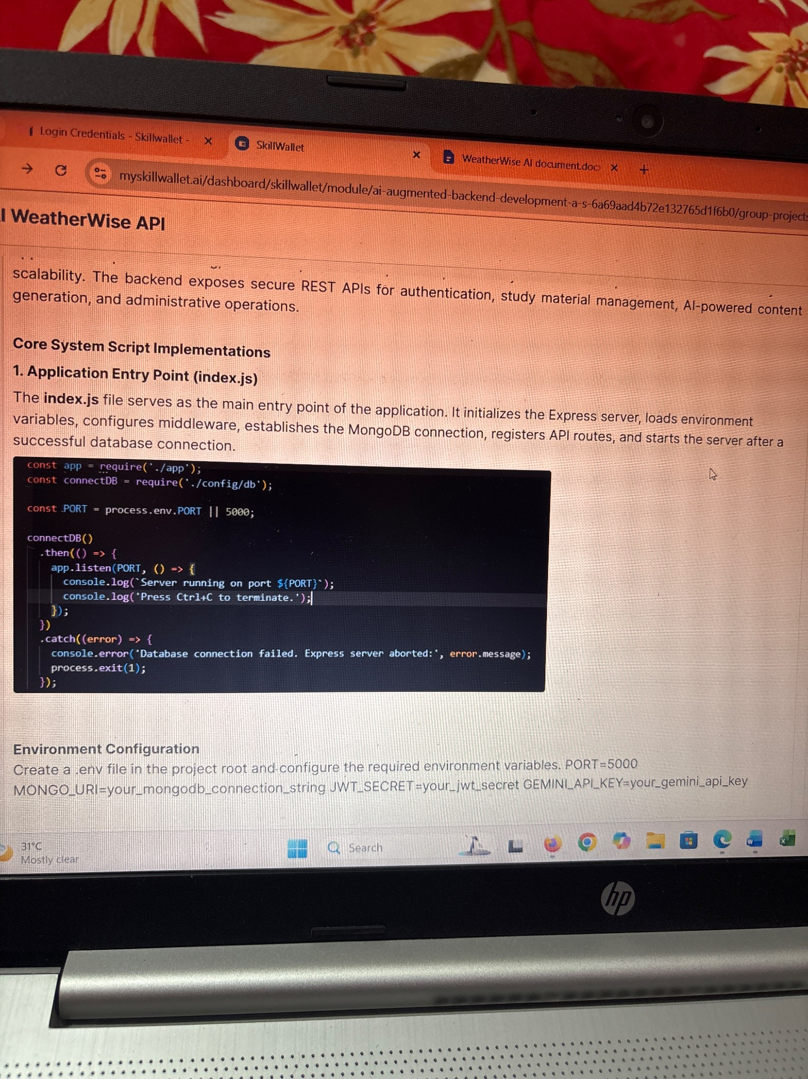

10. Conclusion
The WeatherWise AI API backend provides a structured foundation for a secure and scalable weather and AI application. The index.js entry point ensures that the Express application is initialized correctly, the MongoDB database is connected before the server starts, and database failures are handled safely. Environment variables further improve security by keeping configuration values and API credentials separate from the source code.

